Introduction to Objects

In computer science, an important ideas is that of “objects.”

We use programming objects to represent real-world objects.

**Objects consist of the following.**

1.Properties – These are the characteristics of the objects and they consist of name-value pairs.

2.Actions – These are the actions the object can take and they consist of functions within the object that allow the object.

These functions are called “methods” when they are part of an object.

**Example of a programming object**

Suppose that we wanted to model a hotel with a computer program.

Below are some properties of the hotel.

name

rating

rooms

bookings

pool

Below are some actions of the hotel.

book a room

cancel a booking

check availability

The actions taken by the hotel can change the value of some or all of the properties.

An action is triggered by an event.

An event causes one of the actions to occur which probably changes the value of one of the properties.

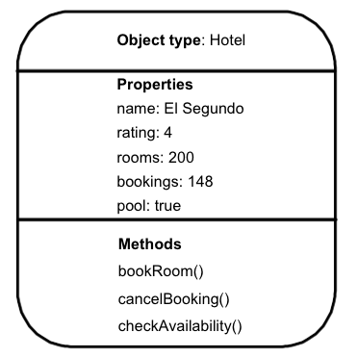

**How are properties, methods, and events connected?**

Suppose a person wants to make a reservation with the El Segundo hotel. They would initiate an event. The event is a reservation. To make the reservation we would call the bookRoom() method which would change the value of the bookings property.

If another person wanted to cancel their reservation at the hotel, they would initiate a cancel event. The cancelBooking() method would be called and the value of the bookings variable would be changed.

**How does a web browser use objects?**

Web browsers are programs that use objects. Web browsers create models of web pages and the window they are shown within.

**Window object properties**

Location: <http://www.myWebstie.com>

**Document object properties**

URL: <http://www.myWebsite.com> -This property stores the URL of the document.

lastModified: 09/04/2017 15:33:48 -This property stores when the document was last modified.

title: My great website written by me -This property stores the title given to the document.

**Document object methods**

write() -This method adds new content to the document.

getElementById() -This method accesses an element by Id and then updates it.

**How does a browser see a web page?**

In order to understand how you can change the content of an HTML page using javascript, you need to know how a browser interprets HTML code and applies styles to it.

The browser uses the following 3 steps to show a web page.

1.Receive a web page as HTML code.

2.Create a model of the web page and store it in memory.

3.Use a rendering engine to show the page on the screen either using default styles or CSS styles.

NOTE: Javascript is run using an interpreter (also known as a scripting engine). The interpreter is part of the browser. The interpreter loads, compiles, and runs script code.

**What does the browser’s model of the web page look like?**

Consider the following web page.

<html>

<head>

<title>My website</title>

<link rel=”stylesheet” href=”myStyles.css” />

</head>

<body>

<h1>This is my website.</h1>

<p>I know you will <em>love my website. </em> </p>

</body>

</html>

The browser views the document using a tree-like structure. At the top is the document object. Each item below it is called a node. Each node is an object. There are three types of nodes represented in the diagram below representing elements, text, and attributes.

